Family Feud Overview
As part of Employee Ownership Month, we had a Family Feud-style educational/fun session. We had two teams of leaders across all disciplines divided between two teams. Questions revolved around employee ownership.
Prior to the session, the questions were sent out to a survey group of employee-owners (we leveraged our Employee Ownership Network – steering committee, core team, support team, and Ambassador Network). The responses had multiple choice answers to limit the variations in results. We used the results of the survey to create the game.
We opened the session with current, upbeat music to energize people and make it fun while we waited for everyone to trickle in from other meetings. Throughout the game, we would take breaks and let our panelists interject and expand on the question topics.
Questions
1. As employee-owners, together, we ___. (phrase)
2. What type of information can you find on the Employee Ownership site? (word/phrase)
3. Name [a leader’s name] favorite food. (could be more than one thing) (fun question)
4. In one word, why are you proud to be an employee-owner? (word)
5. In one word, what does being an employee-owner mean to you? (word)

Team score slide (PowerPoint slide which was updated as the game progressed)

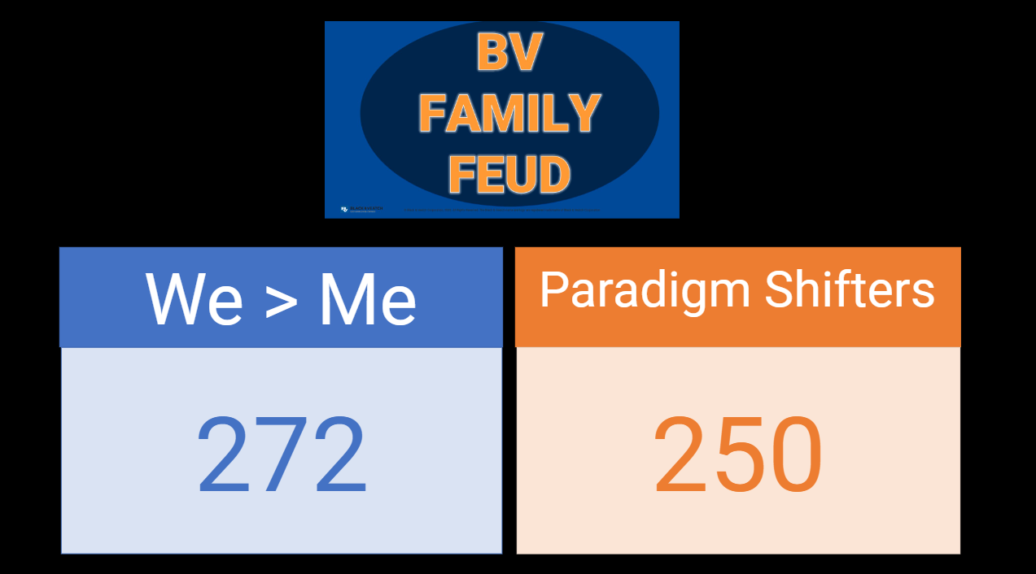
Each team made up their own name

